

**FIGURE 6.6**

Illustration of Lenz’s law.

###### 210

* 1. **LENZ’S LAW AND CONSERVATION OF ENERGY**

In 1834, German physicist Heinrich Friedrich Lenz (1804-1865) deduced a rule, known as *Lenz’s law* which gives the polarity of the induced emf in a clear and concise fashion. The statement of the law is:

*The polarity of induced emf is such that it tends to produce a current which opposes the change in magnetic flux that produced it.*

The negative sign shown in Eq. (6.3) represents this effect. We can understand Lenz’s law by examining Experiment 6.1 in Section 6.2.1. In Fig. 6.1, we see that the North-pole of a bar magnet is being pushed towards the closed coil. As the North-pole of the bar magnet moves towards the coil, the magnetic flux through the coil increases. Hence current is induced in the coil in such a direction that it opposes the increase in flux. This is possible only if the current in the coil is in a counter-clockwise direction with respect to an observer situated on the side of the magnet. Note that magnetic moment associated with this current has North polarity towards the North-pole of the approaching magnet. Similarly, if the North- pole of the magnet is being withdrawn from the coil, the magnetic flux through the coil will decrease. To counter this decrease in magnetic flux, the induced current in the coil flows in clockwise direction and its South- pole faces the receding North-pole of the bar magnet. This would result in an attractive force which opposes the motion of the magnet and the corresponding decrease in flux.

What will happen if an open circuit is used in place of the closed loop

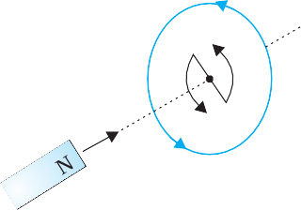in the above example? In this case too, an emf is induced across the open ends of the circuit. The direction of the induced emf can be found using Lenz’s law. Consider Figs. 6.6 (a) and (b). They provide an easier way to understand the direction of induced currents. Note that the

direction shown by and  indicate the directions of the induced currents.

A little reflection on this matter should convince us on the

correctness of Lenz’s law. Suppose that the induced current was in the direction opposite to the one depicted in Fig. 6.6(a). In that case, the South-pole due to the induced current will face the approaching North-pole of the magnet. The bar magnet will then be attracted towards the coil at an ever increasing acceleration. A gentle push on the magnet will initiate the process and its velocity and kinetic energy will continuously increase without expending any energy. If this can happen, one could construct a perpetual-motion machine by a suitable arrangement. This violates the law of conservation of energy and hence can not happen.

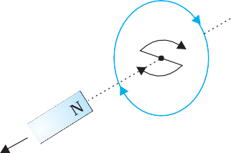

Now consider the correct case shown in Fig. 6.6(a). In this situation, the bar magnet experiences a repulsive force due to the induced

current. Therefore, a person has to do work in moving the magnet.

Where does the energy spent by the person go? This energy is dissipated by Joule heating produced by the induced current.

**Example 6.4**

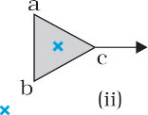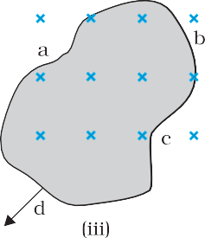

Figure 6.7 shows planar loops of different shapes moving out of or into a region of a magnetic field which is directed normal to the plane of the loop away from the reader. Determine the direction of induced current in each loop using Lenz’s law.

**Solution**

**FIGURE 6.7**

1. The magnetic flux through the rectangular loop abcd increases, due to the motion of the loop into the region of magnetic field, The induced current must flow along the path bcdab so that it opposes the increasing flux.
2. Due to the outward motion, magnetic flux through the triangular loop abc decreases due to which the induced current flows along bacb, so as to oppose the change in flux.

**EXAMPLE 6.4**

1. As the magnetic flux decreases due to motion of the irregular shaped loop abcd out of the region of magnetic field, the induced current flows along cdabc, so as to oppose change in flux.

Note that there are no induced current as long as the loops are completely inside or outside the region of the magnetic field.

###### 211

**Example 6.5**

1. A closed loop is held stationary in the magnetic field between the north and south poles of two permanent magnets held fixed. Can we hope to generate current in the loop by using very strong magnets?
2. A closed loop moves normal to the constant electric field between the plates of a large capacitor. Is a current induced in the loop
   1. when it is wholly inside the region between the capacitor plates
   2. when it is partially outside the plates of the capacitor? The electric field is normal to the plane of the loop.
3. A rectangular loop and a circular loop are moving out of a uniform magnetic field region (Fig. 6.8) to a field-free region with a *constant velocity* **v**. In which loop do you expect the induced emf to be constant *during* the passage out of the field region? The field is normal to the loops.

**EXAMPLE 6.5**



**FIGURE 6.8**

(d) Predict the polarity of the capacitor in the situation described by Fig. 6.9.

**FIGURE 6.9**

**Solution**

1. No. However strong the magnet may be, current can be induced only by changing the magnetic flux through the loop.
2. No current is induced in *either* case. Current can not be induced by changing the electric flux.
3. The induced emf is expected to be constant only in the case of the rectangular loop. In the case of circular loop, the rate of change of area of the loop during its passage out of the field region is not constant, hence induced *emf* will vary accordingly.
4. The polarity of plate ‘A’ will be positive with respect to plate ‘B’ in the capacitor.
   1. **MOTIONAL ELECTROMOTIVE FORCE**

**EXAMPLE 6.5**

Let us consider a straight conductor moving in a uniform and time- independent magnetic field. Figure 6.10 shows a rectangular conductor PQRS in which the conductor PQ is free to move. The rod PQ is moved

towards the left with a constant velocity **v** as shown in the figure. Assume that there is no loss of energy due to friction. PQRS forms a closed circuit enclosing an area that changes as PQ moves. It is placed in a uniform magnetic field **B** which is perpendicular to the plane of this system. If the length RQ = *x* and RS = *l*, the



magnetic flux **B enclosed by the loop PQRS will be

**B = *Blx*



Since *x* is changing with time, the rate of change

**FIGURE 6.10** The arm PQ is moved to the left

of flux **B will induce an emf given by:

side, thus decreasing the area of the

rectangular loop. This movement induces a current *I* as shown.

**  – d*B*

d*t*

 – d d*t*

*Blx* 

###### 212

= – *Bl* d*x*

d*t*

 *Blv*

(6.5)

where we have used d*x*/d*t* = –*v* which is the speed of the conductor PQ. The induced emf *Blv* is called *motional emf*. Thus, we are able to produce induced emf by moving a conductor instead of varying the magnetic field, that is, by changing the magnetic flux enclosed by the circuit.

It is also possible to explain the motional emf expression in Eq. (6.5) by invoking the Lorentz force acting on the free charge carriers of conductor PQ. Consider any arbitrary charge *q* in the conductor PQ. When the rod moves with speed *v*, the charge will also be moving with speed *v* in the magnetic field **B**. The Lorentz force on this charge is *qvB* in magnitude, and its direction is towards Q. All charges experience the same force, in magnitude and direction, irrespective of their position in the rod PQ. The work done in moving the charge from P to Q is,

**Interactive animation on motional emf:** <http://ngsir.netfirms.com/englishhtm/Induction.htm> <http://webphysics.davidson.edu/physlet_resources/bu_semester2/index.html>

W = *qv*B*l*

Since emf is the work done per unit charge,

**  *W*

*q*

= *Blv*

This equation gives emf induced across the rod PQ and is identical to Eq. (6.5). We stress that our presentation is not wholly rigorous. But it does help us to understand the basis of Faraday’s law when the conductor is moving in a uniform and time-independent magnetic field.

On the other hand, it is not obvious how an emf is induced when a conductor is stationary and the magnetic field is changing – a fact which Faraday verified by numerous experiments. In the case of a stationary conductor, the force on its charges is given by

**F =** *q* (**E** + **v  B**) = *q***E** (6.6)

since **v** = 0. Thus, any force on the charge must arise from the electric field term **E** alone. Therefore, to explain the existence of induced emf or induced current, we must assume that a time-varying magnetic field generates an electric field. However, we hasten to add that electric fields produced by static electric charges have properties different from those produced by time-varying magnetic fields. In Chapter 4, we learnt that charges in motion (current) can exert force/torque on a stationary magnet. Conversely, a bar magnet in motion (or more generally, a changing magnetic field) can exert a force on the stationary charge. This is the fundamental significance of the Faraday’s discovery. Electricity and magnetism are related.

###### 213

**Example 6.6** A metallic rod of 1 m length is rotated with a frequency of 50 rev/s, with one end hinged at the centre and the other end at the circumference of a circular metallic ring of radius 1 m, about an axis passing through the centre and perpendicular to the plane of the ring (Fig. 6.11). A constant and uniform magnetic field of 1 T parallel to the axis is present everywhere. What is the emf between the centre and the metallic ring?

**EXAMPLE 6.6**

**FIGURE 6.11**

**Solution**

*Method I*

As the rod is rotated, free electrons in the rod move towards the outer end due to Lorentz force and get distributed over the ring. Thus, the resulting separation of charges produces an emf across the ends of the rod. At a certain value of emf, there is no more flow of electrons and a steady state is reached. Using Eq. (6.5), the magnitude of the emf generated across a length d*r* of the rod as it moves at right angles to the magnetic field is given by

d**  *Bv* d*r* . Hence,

*R*

**   d**  *Bv* d*r*

*R* 2

 *B r* d*r* 

*B R*

⇩ 

2

0 0

Note that we have used *v =  r*. This gives

 1  1.0  2  50  (12 )

**

2

= 157 V

*Method II*

To calculate the emf, we can imagine a closed loop OPQ in which point O and P are connected with a resistor *R* and OQ is the rotating rod. The potential difference across the resistor is then equal to the induced emf and equals *B ×* (rate of change of area of loop). If ** is the angle between the rod and the radius of the circle at P at time *t*, the area of the sector OPQ is given by

❐ *R*2  * *  1 *R*2**

2 2

where *R* is the radius of the circle. Hence, the induced emf is

*B*  d ⎡1 *R*2**⎤ 1

2 d**

*BR*2

** = d*t* ⎢⎣2

**EXAMPLE 6.6**

⎥⎦ =

2 *BR*

d*t*  2

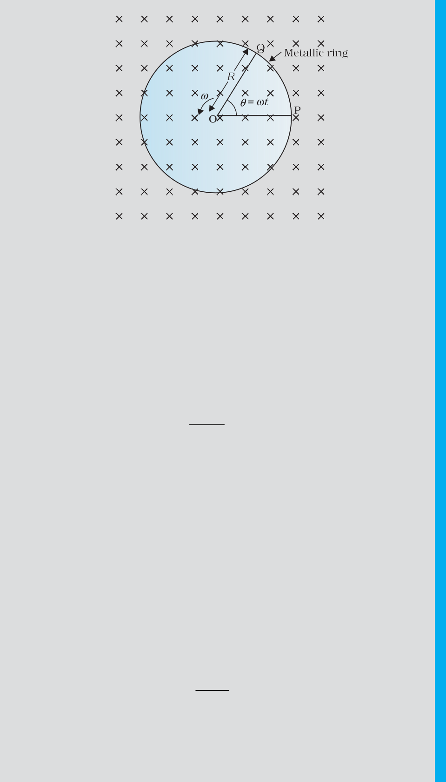

###### 214

[Note: d**  **  2  ** ]

d*t*

This expression is identical to the expression obtained by Method I and we get the same value of **.

**Example 6.7**

A wheel with 10 metallic spokes each 0.5 m long is rotated with a speed of 120 rev/min in a plane normal to the horizontal component of earth’s magnetic field *HE* at a place. If *HE* = 0.4 G at the place, what is the induced emf between the axle and the rim of the wheel? Note

that 1 G = 10–4 T.

**Solution**

Induced emf = (1/2) * B R*2

= (1/2) × 4 × 0.4 × 10–4 × (0.5)2

= 6.28 × 10–5 V

The number of spokes is immaterial because the emf’s across the spokes are *in parallel*.

##### ENERGY CONSIDERATION: A QUANTITATIVE STUDY

**EXAMPLE 6.7**

In Section 6.5, we discussed qualitatively that Lenz’s law is consistent with the law of conservation of energy. Now we shall explore this aspect further with a concrete example.

Let *r* be the resistance of movable arm PQ of the rectangular conductor shown in Fig. 6.10. We assume that the remaining arms QR, RS and SP have negligible resistances compared to *r*. Thus, the overall resistance of the rectangular loop is *r* and this does not change as PQ is moved. The current *I* in the loop is,

*I*  **

*r*

= *Bl v*

*r*

(6.7)

On account of the presence of the magnetic field, there will be a force

on the arm PQ. This force *I* (**l  B**), is directed outwards in the direction opposite to the velocity of the rod. The magnitude of this force is,

*B*2*l* 2*v*

*F* = *I l B* =

*r*

where we have used Eq. (6.7). Note that this force arises due to drift velocity

of charges (responsible for current) along the rod and the consequent Lorentz force acting on them.

Alternatively, the arm PQ is being pushed with a constant speed *v*, the power required to do this is,

*P*  *F v*

*B*2*l* 2*v*2

= (6.8)

*r*

The agent that does this work is mechanical. Where does this

mechanical energy go? The answer is: it is dissipated as Joule heat, and is given by

*P*  *I* 2*r*

⎛ *Blv* ⎞ 2



*r*

 *B*2*l* 2*v*2

*J* ⎜⎝ *r* ⎟⎠ *r*

which is identical to Eq. (6.8).

215

Thus, mechanical energy which was needed to move the arm PQ is converted into electrical energy (the induced emf) and then to thermal energy. There is an interesting relationship between the charge flow through the circuit and the change in the magnetic flux. From Faraday’s law, we

have learnt that the magnitude of the induced emf is,

**  **B

*t*

However,

**  *Ir*  *Q r*

*t*

Thus,

*Q*  **B

*r*

**Example 6.8** Refer to Fig. 6.12(a). The arm PQ of the rectangular conductor is moved from *x* = 0, outwards. The uniform magnetic field is perpendicular to the plane and extends from *x* = 0 to *x = b* and is zero for *x > b*. Only the arm PQ possesses substantial resistance *r*. Consider the situation when the arm PQ is pulled outwards from *x* = 0 to *x =* 2*b*, and is then moved back to *x* = 0 with constant speed *v*. Obtain expressions for the flux, the induced emf, the force necessary to pull the arm and the power dissipated as Joule heat. Sketch the variation of these quantities with distance.

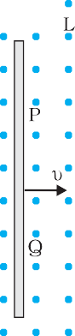

(a)

**FIGURE 6.12**

**Solution** Let us first consider the forward motion from *x* = 0 to *x =* 2*b* The flux **B linked with the circuit SPQR is

**B  *Bl x*

0  *x*  *b*

 *Bl b b*  *x*  2*b*

**EXAMPLE 6.8**

The induced emf is,

**   d**B

d*t*

###### 216

 *Blv*

 0

0  *x*  *b*

*b*  *x*  2*b*



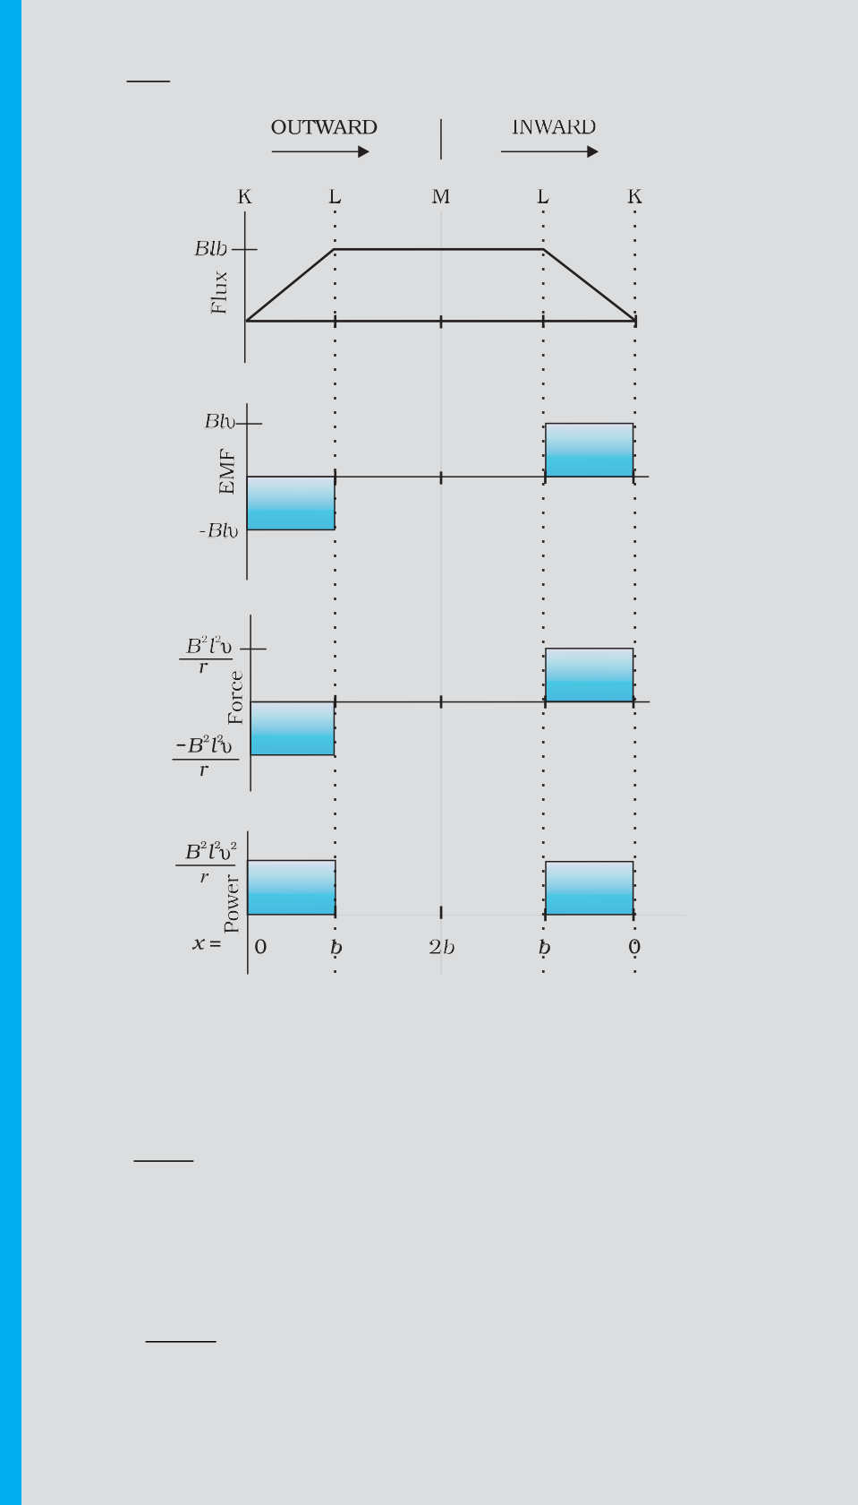

When the induced emf is non-zero, the current *I* is (in magnitude)

*I*  *Bl v*

*r*

(b)

**FIGURE 6.12**

The force required to keep the arm PQ in constant motion is *I l B*. Its direction is to the left. In magnitude

*B*2*l* 2*v*

*F* 

*r*

 0

0  *x*  *b*

*b*  *x*  2*b*

The Joule heating loss is

*P*  *I* 2*r*

*J*

 *B l v*

2 2 2

*r*

 0

0  *x*  *b*

*b*  *x*  2*b*

One obtains similar expressions for the inward motion from *x =* 2*b* to

*x* = 0. One can appreciate the whole process by examining the sketch of various quantities displayed in Fig. 6.12(b).

###### 217

**EXAMPLE 6.8**

* 1. **EDDY CURRENTS**

So far we have studied the electric currents induced in well defined paths in conductors like circular loops. Even when bulk pieces of conductors are subjected to changing magnetic flux, induced currents

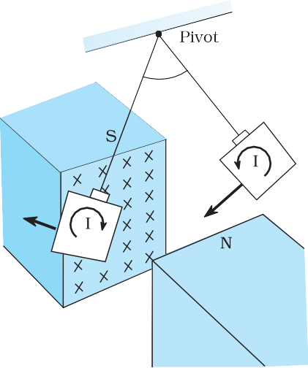are produced in them. However, their flow patterns resemble swirling eddies in water. This effect was discovered by physicist Foucault (1819-1868) and these currents are called *eddy currents*.

Consider the apparatus shown in Fig. 6.13. A copper plate is allowed to swing like a simple pendulum between the pole pieces of a strong magnet. It is found that the motion is damped and in a little while the plate comes to a halt in the magnetic field. We can explain this phenomenon on the basis of electromagnetic induction. Magnetic flux associated with the plate keeps on changing as the plate moves in and out of the region between magnetic poles. The flux change induces eddy currents in the plate. Directions of eddy currents are opposite when the plate swings into the region between the poles and when it swings out of the region.

If rectangular slots are made in the copper plate as shown

**FIGURE 6.13** Eddy currents are generated in the copper plate, while entering

and leaving the region of magnetic field.

in Fig. 6.14, area available to the flow of eddy currents is less. Thus, the pendulum plate with holes or slots reduces electromagnetic damping and the plate swings more freely. Note that magnetic moments of the induced currents (which oppose the motion) depend upon the area enclosed by the currents (recall equation **m** = *I* **A** in Chapter 4).

This fact is helpful in reducing eddy currents in the metallic

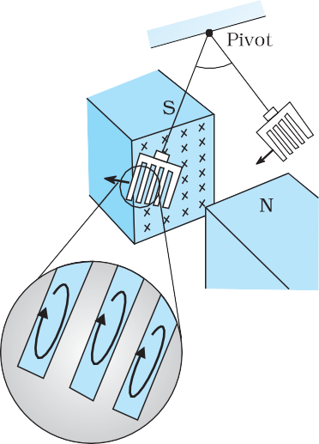

**FIGURE 6.14** Cutting slots in the copper plate reduces the effect of eddy currents.

###### 218

cores of transformers, electric motors and other such devices in which a coil is to be wound over metallic core. Eddy currents are undesirable since they heat up the core and dissipate electrical energy in the form of heat. Eddy currents are minimised by using laminations of metal to make a metal core. The laminations are separated by an insulating material like lacquer. The plane of the laminations must be arranged parallel to the magnetic field, so that they cut across the eddy current paths. This arrangement reduces the strength of the eddy currents. Since the dissipation of electrical energy into heat depends on the square of the strength of electric current, heat loss is substantially reduced.

Eddy currents are used to advantage in certain applications like:

1. *Magnetic braking in trains*: Strong electromagnets are situated above the rails in some electrically powered trains. When the electromagnets are activated, the eddy currents induced in the rails oppose the motion of the train. As there are no mechanical linkages, the braking effect is smooth.
2. *Electromagnetic damping*: Certain galvanometers have a fixed core made of nonmagnetic metallic material. When the coil oscillates, the eddy currents generated in the core oppose the motion and bring the coil to rest quickly.
3. *Induction furnace*: Induction furnace can be used to produce high temperatures and can be utilised to prepare alloys, by melting the constituent metals. A high frequency alternating current is passed through a coil which surrounds the metals to be melted. The eddy currents generated in the metals produce high temperatures sufficient to melt it.
4. *Electric power meters*: The shiny metal disc in the electric power meter (analogue type) rotates due to the eddy currents. Electric currents are induced in the disc by magnetic fields produced by sinusoidally varying currents in a coil.

You can observe the rotating shiny disc in the power meter of your house.

**ELECTROMAGNETIC DAMPING**

Take two hollow thin cylindrical pipes of equal internal diameters made of aluminium and PVC, respectively. Fix them vertically with clamps on retort stands. Take a small cylinderical magnet having diameter slightly smaller than the inner diameter of the pipes and drop it through each pipe in such a way that the magnet does not touch the sides of the pipes during its fall. You will observe that the magnet dropped through the PVC pipe takes the same time to come out of the pipe as it would take when dropped through the same height without the pipe. Note the time it takes to come out of the pipe in each case. You will see that the magnet takes much longer time in the case of aluminium pipe. Why is it so? It is due to the eddy currents that are generated in the aluminium pipe which oppose the change in magnetic flux, i.e., the motion of the magnet. The retarding force due to the eddy currents inhibits the motion of the magnet. Such phenomena are referred to as *electromagnetic damping*. Note that eddy currents are not generated in PVC pipe as its material is an insulator whereas aluminium is a conductor.

##### INDUCTANCE

An electric current can be induced in a coil by flux change produced by another coil in its vicinity or flux change produced by the same coil. These two situations are described separately in the next two sub-sections. However, in both the cases, the flux through a coil is proportional to the current. That is, **B  *I*.

Further, if the geometry of the coil does not vary with time then,

d*B* d*t*

✪ d*I*

d*t*

For a closely wound coil of *N* turns, the same magnetic flux is linked with all the turns. When the flux **B through the coil changes, each turn contributes to the induced emf. Therefore, a term called *flux linkage* is used which is equal to *N*B for a closely wound coil and in such a case

*N*B  *I*

The constant of proportionality, in this relation, is called *inductance*. We shall see that inductance depends only on the geometry of the coil

###### 219

and intrinsic material properties. This aspect is akin to capacitance which for a parallel plate capacitor depends on the plate area and plate separation (geometry) and the dielectric constant *K* of the intervening medium (intrinsic material property).

Inductance is a scalar quantity. It has the dimensions of [M L2 T –2 A–2] given by the dimensions of flux divided by the dimensions of current. The SI unit of inductance is *henry* and is denoted by H. It is named in honour of Joseph Henry who discovered electromagnetic induction in USA, independently of Faraday in England.

* + 1. **Mutual inductance**

Consider Fig. 6.15 which shows two long co-axial solenoids each of length

*l*. We denote the radius of the inner solenoid *S*1 by *r*1 and the number of turns per unit length by *n*1. The corresponding quantities for the outer solenoid *S*2 are *r*2 and *n*2, respectively. Let *N*1 and *N*2 be the total number of turns of coils *S*1 and *S*2, respectively.

When a current *I*2 is set up through *S*2, it in turn sets up a magnetic

flux through *S*1. Let us denote it by **1. The corresponding flux linkage with solenoid *S*1 is

*N*1 **1  *M*12 *I*2

(6.9)

*M*12 is called the *mutual inductance* of solenoid *S*1 with respect to solenoid *S*2. It is also referred to as the *coefficient of mutual induction*.

For these simple co-axial solenoids it is possible to calculate *M*12. The

magnetic field due to the current *I*2 in *S*2 is **0*n*2*I*2. The resulting flux linkage with coil *S*1 is,

*N *  *n l*  *r* 2  * n I* 

1 1 1 1 0 2 2

 * nn* *r* 2*l I*

0 1 2 1 2

(6.10)

where *n*1*l* is the total number of turns in solenoid *S*1. Thus, from Eq. (6.9) and Eq. (6.10),

*M* = * n n* *r* 2*l* (6.11)

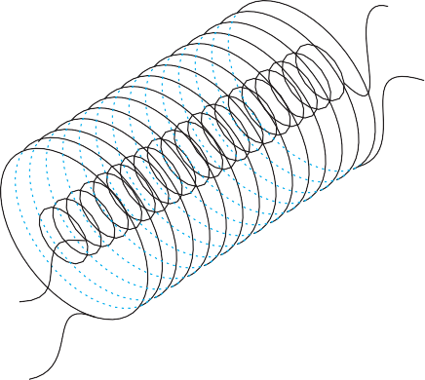

12 0 1 2 1



**FIGURE 6.15** Two long co-axial solenoids of same

Note that we neglected the edge effects and considered the magnetic field **0*n*2*I*2 to be uniform throughout the length and width of the solenoid *S*2. This is a good approximation keeping in mind that the solenoid is long, implying *l* >> *r*2.

We now consider the reverse case. A current *I*1 is

passed through the solenoid *S*1 and the flux linkage with coil *S*2 is,

*N*2**2 = *M*21 *I*1 (6.12)

*M*21 is called the *mutual inductance* of solenoid *S*2 with respect to solenoid *S*1.

The flux due to the current *I*1 in *S*1 can be assumed to be confined solely inside *S*1 since the solenoids are very long. Thus, flux linkage with solenoid *S*2 is

2 2 2 1 0 1 1

###### 220

length *l.*

*N *  *n l*  *r* 2  * n I* 

where *n*2*l* is the total number of turns of S2. From Eq. (6.12),

*M* = * n n* *r* 2*l* (6.13)

21 0 1 2 1

Using Eq. (6.11) and Eq. (6.12), we get

*M*12 = *M*21= *M* (say) (6.14)

We have demonstrated this equality for long co-axial solenoids. However, the relation is far more general. Note that if the inner solenoid was much shorter than (and placed well inside) the outer solenoid, then

we could still have calculated the flux linkage *N*1**1 because the inner solenoid is effectively immersed in a uniform magnetic field due to the outer solenoid. In this case, the calculation of *M*12 would be easy. However, it would be extremely difficult to calculate the flux linkage with the outer solenoid as the magnetic field due to the inner solenoid would vary across the length as well as cross section of the outer solenoid. Therefore, the calculation of *M*21 would also be extremely difficult in this case. The equality *M*12=*M*21 is very useful in such situations.

We explained the above example with air as the medium within the

solenoids. Instead, if a medium of relative permeability **r had been present, the mutual inductance would be

*M* =*  n n*  *r*2 *l*

*r* 0 1 2 1

It is also important to know that the mutual inductance of a pair of coils, solenoids, etc., depends on their separation as well as their relative orientation.

###### 221

**Example 6.9** Two concentric circular coils, one of small radius *r*1 and the other of large radius *r*2, such that *r*1 << *r*2, are placed co-axially with centres coinciding. Obtain the mutual inductance of the arrangement.

**Solution** Let a current *I2* flow through the outer circular coil. The field at the centre of the coil is *B*2 = **0*I*2 / 2*r*2. Since the other co-axially placed coil has a very small radius, *B*2 may be considered constant over its cross-sectional area. Hence,

** = *r* 2*B*

1 1 2



** 

2*r*2

0 1 *I*2

*r*

2

= *M*12 *I*2

Thus,

*M*12 

** *r* 2

0 1

2*r*2

From Eq. (6.14)

*M*12  *M* 21 

*  r* 2

0 1

2*r*2

Note that we calculated *M*12 from an approximate value of **1, assuming

2

can accept this value because *r*1 << *r*2.

the magnetic field *B* to be uniform over the area  *r* 2. However, we

1

**EXAMPLE 6.9**

Now, let us recollect Experiment 6.3 in Section 6.2. In that experiment, emf is induced in coil *C*1 wherever there was any change in current through coil *C*2. Let **1 be the flux through coil *C*1 (say of *N*1 turns) when current in coil *C*2 is *I*2.

Then, from Eq. (6.9), we have

*N*1**1 = *MI*2

For currents varrying with time,

d*N*1**1   d*MI*2 

d*t* d*t*

Since induced emf in coil *C*1 is given by

**  – d*N*1**1 

 d*t*

We get,

**  –*M* d*I*2

 d*t*

It shows that varying current in a coil can induce emf in a neighbouring coil. The magnitude of the induced emf depends upon the rate of change of current and mutual inductance of the two coils.

#### Self-inductance

In the previous sub-section, we considered the flux in one solenoid due to the current in the other. It is also possible that emf is induced in a single isolated coil due to change of flux through the coil by means of varying the current through the same coil. This phenomenon is called *self-induction*. In this case, flux linkage through a coil of *N* turns is proportional to the current through the coil and is expressed as

*NB*  *I*

*NB*  *L I*

(6.15)

where constant of proportionality *L* is called *self-inductance* of the coil. It is also called the *coefficient of self-induction* of the coil. When the current is varied, the flux linked with the coil also changes and an emf is induced in the coil. Using Eq. (6.15), the induced emf is given by

**  – d*N*B 

d*t*

**  –*L* d*I*

d*t*

(6.16)

###### 222

Thus, the self-induced emf always opposes any change (increase or decrease) of current in the coil.

It is possible to calculate the self-inductance for circuits with simple geometries. Let us calculate the self-inductance of a long solenoid of cross- sectional area *A* and length *l*, having *n* turns per unit length. The magnetic

field due to a current *I* flowing in the solenoid is *B* = **0 *n I* (neglecting edge effects, as before). The total flux linked with the solenoid is

*NB*  *nl*  **0*n I*   *A*

 * n* 2*Al I*

0

where *nl* is the total number of turns. Thus, the self-inductance is,

*L*  **

*I*

 * n* 2 *Al*

0

(6.17)

If we fill the inside of the solenoid with a material of relative permeability

*r* (for example soft iron, which has a high value of relative permiability), then,

*L*  *r *0

*n* 2 *Al*

(6.18)

The self-inductance of the coil depends on its geometry and on the permeability of the medium.

The self-induced emf is also called the *back emf* as it opposes any change in the current in a circuit. Physically, the *self-inductance plays the role of inertia*. It is the electromagnetic analogue of mass in mechanics. So, work needs to be done against the back emf (** ) in establishing the current. This work done is stored as magnetic potential energy. For the current *I* at an instant in a circuit, the rate of work done is

d*W*  * I*

d*t*

If we ignore the resistive losses and consider only inductive effect, then using Eq. (6.16),

d*W*  *L I* d*I* d*t* d*t*

Total amount of work done in establishing the current *I* is

*W*   d*W*

*I*

  *L I* d*I*

0

Thus, the energy required to build up the current *I* is,

*W*  1 *LI* 2

2

(6.19)

This expression reminds us of *mv* 2/2 for the (mechanical) kinetic energy of a particle of mass *m*, and shows that *L* is analogus to *m* (i.e., *L* is electrical inertia and opposes growth and decay of current in the circuit).

Consider the general case of currents flowing simultaneously in two nearby coils. The flux linked with one coil will be the sum of two fluxes which exist independently. Equation (6.9) would be modified into

*N*1 **1  *M*11 *I*1  *M*12 *I*2

where *M*11 represents inductance due to the same coil.

Therefore, using Faraday’s law,

223

**  *M*

d*I*1  *M*

d*I*2

1 11 d*t* 12 d*t*

*M*11 is the *self-inductance* and is written as *L*1. Therefore,

**  *L*

d*I*1  *M*

d*I*2

1 1 d*t* 12 d*t*

**Example 6.10** (a) Obtain the expression for the magnetic energy stored in a solenoid in terms of magnetic field *B*, area *A* and length *l* of the solenoid. (b) How does this magnetic energy compare with the electrostatic energy stored in a capacitor?

**Solution**

1. From Eq. (6.19), the magnetic energy is

*U*  1 *LI* 2

**Interactive animation on ac generator:**

<http://micro.magnet.fsu.edu/electromag/java/generator/ac.html>

*B* 2

1 ⎛ *B* ⎞ 2

 2 *L* ⎜⎝ * n* ⎟⎠

*0*

1 ⎛ *B* ⎞ 2

since *B*  *0nI*,for a solenoid

 (* n* 2 *Al* )

0 ⎜ ⎟

2 ⎝ **0*n* ⎠

[from Eq. (6.17)]

 1 *B*2 *Al*

2**0

1. The magnetic energy per unit volume is,

*u*  *UB*

*B V*

 *UB*

*Al*

(where *V* is volume that contains flux)

 *B*2

2**0

(6.20)

We have already obtained the relation for the electrostatic energy stored per unit volume in a parallel plate capacitor (refer to Chapter 2, Eq. 2.77),

*u*  1 * E* 2

**EXAMPLE 6.10**

(2.77)

** 2 0

In both the cases energy is proportional to the square of the field strength. Equations (6.20) and (2.77) have been derived for special cases: a solenoid and a parallel plate capacitor, respectively. But they are general and valid for any region of space in which a magnetic field or/and an electric field exist.

###### 224

* 1. **AC GENERATOR**

The phenomenon of electromagnetic induction has been technologically exploited in many ways. An exceptionally important application is the generation of alternating currents (ac). The modern ac generator with a typical output capacity of 100 MW is a highly evolved machine. In this section, we shall describe the basic principles behind this machine. The Yugoslav inventor Nicola Tesla is credited with the development of the machine. As was pointed out in Section 6.3, one method to induce an emf

or current in a loop is through a change in the loop’s orientation or a change in its effective area. As the coil rotates in a magnetic field **B**, the effective area of the loop (the face perpendicular to the field) is *A* cos ** where ** is the angle between **A** and **B**. This method of producing a flux change is the principle of operation of a simple ac generator. An ac generator converts mechanical energy into electrical energy.

The basic elements of an ac generator are shown in Fig. 6.16. It consists of a coil mounted on a rotor shaft. The axis of rotation of the coil is perpendicular to the direction of the magnetic field. The coil (called armature) is mechanically rotated in the uniform magnetic field by some external means. The rotation of the coil causes the magnetic flux through it to change, so an emf is induced in the coil. The ends of the coil are connected to an external circuit by means of slip rings and brushes.

When the coil is rotated with a constant

**FIGURE 6.16** AC Generator

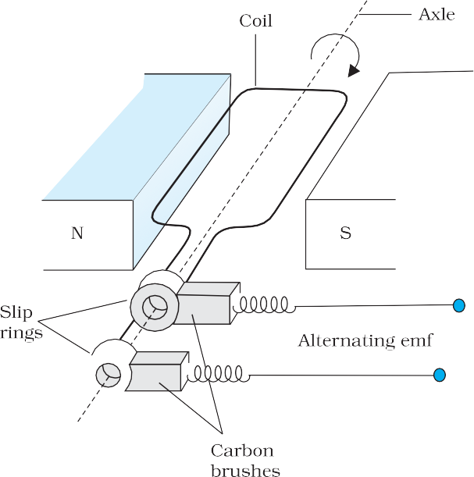

angular speed **, the angle ** between the magnetic field vector **B** and the area vector **A** of the coil at any instant *t* is ** = *t* (assuming ** = 0º at *t* = 0). As a result, the effective area of the coil exposed to the magnetic field lines changes with time, and from Eq. (6.1), the flux at any time *t* is

**B = *BA* cos * = BA* cos *t*

From Faraday’s law, the induced emf for the rotating coil of *N* turns is then,

**  – *N* d*B*  – *NBA* d (cos * t* ) dt d*t*

Thus, the instantaneous value of the emf is

**  *NBA  sin t* (6.21)

where *NBA* is the maximum value of the emf, which occurs when sin *t*  1. If we denote *NBA* as **0, then

** = **0 sin *t* (6.22)

Since the value of the sine fuction varies between +1 and –1, the sign, or polarity of the emf changes with time. Note from Fig. 6.17 that the emf has its extremum value when ** = 90º or ** = 270º, as the change of flux is greatest at these points.

The direction of the current changes periodically and therefore the current is called *alternating current* (ac). Since ** = 2**, Eq (6.22) can be written as

** = **0sin 2 * t* (6.23)

where ** is the frequency of revolution of the generator’s coil.

Note that Eq. (6.22) and (6.23) give the instantaneous value of the emf and ** varies between +**0 and –**0 periodically. We shall learn how to determine the time-averaged value for the alternating voltage and current in the next chapter.

###### 225

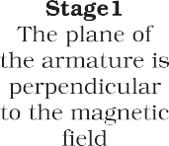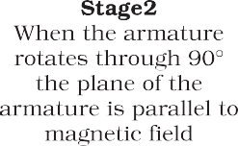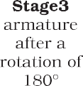

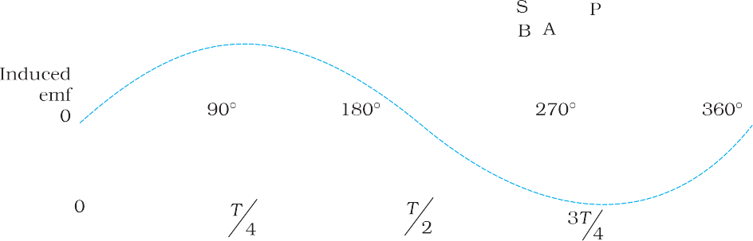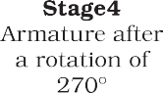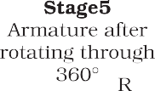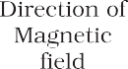

**FIGURE 6.17** An alternating emf is generated by a loop of wire rotating in a magnetic field.

In commercial generators, the mechanical energy required for rotation of the armature is provided by water falling from a height, for example, from dams. These are called *hydro-electric generators*. Alternatively, water is heated to produce steam using coal or other sources. The steam at high pressure produces the rotation of the armature. These are called *thermal generators*. Instead of coal, if a nuclear fuel is used, we get *nuclear power generators*. Modern day generators produce electric power as high as 500 MW, i.e., one can light up 5 million 100 W bulbs! In most generators, the coils are held stationary and it is the electromagnets which are rotated. The frequency of rotation is 50 Hz in India. In certain countries such as USA, it is 60 Hz.

###### 226

**Example 6.11** Kamla peddles a stationary bicycle the pedals of the bicycle are attached to a 100 turn coil of area 0.10 m2. The coil rotates at half a revolution per second and it is placed in a uniform magnetic field of 0.01 T perpendicular to the axis of rotation of the coil. What is the maximum voltage generated in the coil?

**Solution** Here *f* = 0.5 Hz; *N* =100, *A* = 0.1 m2 and *B* = 0.01 T. Employing Eq. (6.21)

** = *NBA (*2  *)*

= 100 × 0.01 × 0.1 × 2 × 3.14 × 0.5

= 0.314 V

The maximum voltage is 0.314 V.

We urge you to explore such alternative possibilities for power generation.

**EXAMPLE 6.11**

**MIGRATION OF BIRDS**

The migratory pattern of birds is one of the mysteries in the field of biology, and indeed all of science. For example, every winter birds from Siberia fly unerringly to water spots in the Indian subcontinent. There has been a suggestion that electromagnetic induction may provide a clue to these migratory patterns. The earth’s magnetic field has existed throughout evolutionary history. It would be of great benefit to migratory birds to use this field to determine the direction. As far as we know birds contain no ferromagnetic material. So electromagnetic induction seems to be the only reasonable mechanism to determine direction. Consider the optimal case where the magnetic field **B**, the velocity of the bird **v**, and two relevant points of its anatomy separated by a distance *l*, all three are mutually perpendicular. From the formula for motional emf, Eq. (6.5),

** = *Blv*

Taking *B* = 4 × 10–5 T, *l* = 2 cm wide, and *v* = 10 m/s, we obtain

** = 4 × 10–5 × 2 × 10–2 × 10 V = 8 × 10–6 V

= 8 V

This extremely small potential difference suggests that our hypothesis is of doubtful validity. Certain kinds of fish are able to detect small potential differences. However, in these fish, special cells have been identified which detect small voltage differences. In birds no such cells have been identified. Thus, the migration patterns of birds continues to remain a mystery.

227

**SUMMARY**

1. The magnetic flux through a surface of area **A** placed in a uniform magnetic field **B** is defined as,

**B = **B****A** = *BA* cos **

where ** is the angle between **B** and **A**.

1. Faraday’s laws of induction imply that the emf induced in a coil of *N*

turns is directly related to the rate of change of flux through it,

3.

4.

5.

6.

d*t*

Here ** is the flux linked with one turn of the coil. If the circuit is closed, a current *I* = /*R* is set up in it, where *R* is the resistance of the circuit.

Lenz’s law states that the polarity of the induced emf is such that it tends to produce a current which opposes the change in magnetic flux that produces it. The negative sign in the expression for Faraday’s law indicates this fact.

When a metal rod of length *l* is placed normal to a uniform magnetic field *B* and moved with a velocity *v* perpendicular to the field, the induced emf (called motional emf) across its ends is

** = *Blv*

Changing magnetic fields can set up current loops in nearby metal (any conductor) bodies. They dissipate electrical energy as heat. Such currents are called eddy currents.

Inductance is the ratio of the flux-linkage to current. It is equal to *N*/*I*.

**  *N* d**B

7. A changing current in a coil (coil 2) can induce an emf in a nearby coil

(coil 1). This relation is given by,

**  *M*

1

d*I* 2

12 d*t*

The quantity *M*12 is called mutual inductance of coil 1 with respect to coil 2. One can similarly define *M*21. There exists a general equality,

*M*12 = *M*21

8. When a current in a coil changes, it induces a back emf in the same coil. The self-induced emf is given by,

**  *L* d*I*

d*t*

*L* is the self-inductance of the coil. It is a measure of the inertia of the coil against the change of current through it.

9. The self-inductance of a long solenoid, the core of which consists of a magnetic material of permeability **r, is given by

*L* = *  n Al*

*2*

*r 0*

where *A* is the area of cross-section of the solenoid, *l* its length and *n*

the number of turns per unit length.

10. In an ac generator, mechanical energy is converted to electrical energy by virtue of electromagnetic induction. If coil of *N* turn and area *A* is rotated at ** revolutions per second in a uniform magnetic field *B,* then the motional emf produced is

** = *NBA* ( 2**) sin (2 *t*)

where we have assumed that at time *t =* 0 s, the coil is perpendicular to the field.

|  |  |  |  |  |
| --- | --- | --- | --- | --- |
| **Quantity** | **Symbol** | **Units** | **Dimensions** | **Equations** |
| Magnetic Flux | **B | Wb (weber) | [M L2 T –2 A–1] | **B = **B**  **A** |
| EMF  Mutual Inductance | **  *M* | V (volt)  H (henry) | [M L2 T –3 A–1]  [M L2 T –2 A–2] | ** = d(*N*B )/ d*t*  **1  *M*12 d*I*2 / d*t*  |
| Self Inductance | *L* | H (henry) | [M L2 T –2 A–2] | **  *L* d*I* / d*t*  |

###### 228

**POINTS TO PONDER**

1. Electricity and magnetism are intimately related. In the early part of the nineteenth century, the experiments of Oersted, Ampere and others established that moving charges (currents) produce a magnetic field. Somewhat later, around 1830, the experiments of Faraday and Henry demonstrated that a moving magnet can induce electric current.
2. In a closed circuit, electric currents are induced so as to oppose the changing magnetic flux. It is as per the law of conservation of energy. However, in case of an open circuit, an emf is induced across its ends. How is it related to the flux change?
3. The motional emf discussed in Section 6.5 can be argued independently from Faraday’s law using the Lorentz force on moving charges. However,



even if the charges are stationary [and the *q* (**v** × **B**) term of the Lorentz force is not operative], an emf is nevertheless induced in the presence of a time-varying magnetic field. Thus, moving charges in static field and static charges in a time-varying field seem to be symmetric situation for Faraday’s law. This gives a tantalising hint on the relevance of the principle of relativity for Faraday’s law.

4. The motion of a copper plate is damped when it is allowed to oscillate between the magnetic pole-pieces. How is the damping force, produced by the eddy currents?

**EXERCISES**

* 1. Predict the direction of induced current in the situations described by the following Figs. 6.18(a) to (f ).

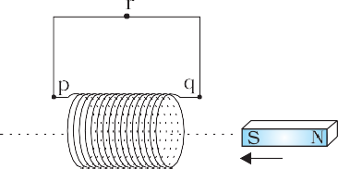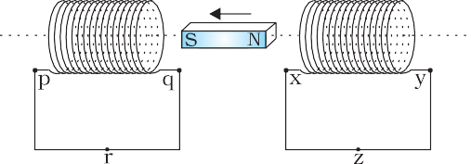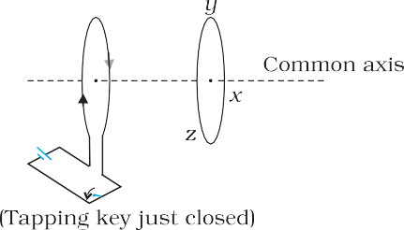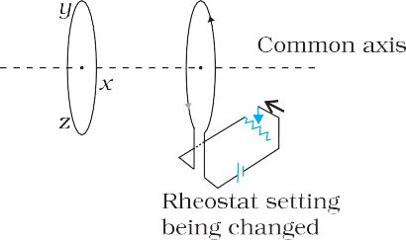

 

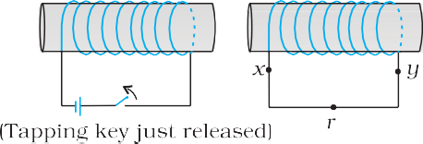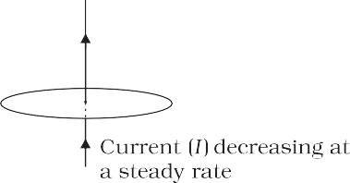

**FIGURE 6.18**

###### 229

* 1. Use Lenz’s law to determine the direction of induced current in the situations described by Fig. 6.19:
     1. A wire of irregular shape turning into a circular shape;
     2. A circular loop being deformed into a narrow straight wire.

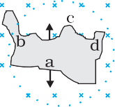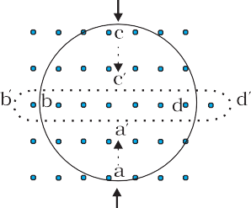

 

###### 230

**FIGURE 6.19**

* 1. A long solenoid with 15 turns per cm has a small loop of area 2.0 cm2 placed inside the solenoid normal to its axis. If the current carried by the solenoid changes steadily from 2.0 A to 4.0 A in 0.1 s, what is the induced emf in the loop while the current is changing?
  2. A rectangular wire loop of sides 8 cm and 2 cm with a small cut is moving out of a region of uniform magnetic field of magnitude 0.3 T directed normal to the loop. What is the emf developed across the cut if the velocity of the loop is 1 cm s–1 in a direction normal to the
     1. longer side, (b) shorter side of the loop? For how long does the induced voltage last in each case?
  3. A 1.0 m long metallic rod is rotated with an angular frequency of 400 rad s–1 about an axis normal to the rod passing through its one end. The other end of the rod is in contact with a circular metallic ring. A constant and uniform magnetic field of 0.5 T parallel to the axis exists everywhere. Calculate the emf developed between the centre and the ring.
  4. A circular coil of radius 8.0 cm and 20 turns is rotated about its vertical diameter with an angular speed of 50 rad s–1 in a uniform horizontal magnetic field of magnitude 3.0  10–2 T. Obtain the maximum and average emf induced in the coil. If the coil forms a closed loop of resistance 10 , calculate the maximum value of current in the coil. Calculate the average power loss due to Joule heating. Where does this power come from?
  5. A horizontal straight wire 10 m long extending from east to west is falling with a speed of 5.0 m s–1, at right angles to the horizontal component of the earth’s magnetic field, 0.30  10–4 Wb m–2.
     1. What is the instantaneous value of the emf induced in the wire?
     2. What is the direction of the emf?
     3. Which end of the wire is at the higher electrical potential?
  6. Current in a circuit falls from 5.0 A to 0.0 A in 0.1 s. If an average emf of 200 V induced, give an estimate of the self-inductance of the circuit.
  7. A pair of adjacent coils has a mutual inductance of 1.5 H. If the current in one coil changes from 0 to 20 A in 0.5 s, what is the change of flux linkage with the other coil?
  8. A jet plane is travelling towards west at a speed of 1800 km/h. What is the voltage difference developed between the ends of the wing

having a span of 25 m, if the Earth’s magnetic field at the location has a magnitude of 5 × 10–4 T and the dip angle is 30°.

# ADDITIONAL EXERCISES

* 1. Suppose the loop in Exercise 6.4 is stationary but the current feeding the electromagnet that produces the magnetic field is gradually reduced so that the field decreases from its initial value of 0.3 T at the rate of 0.02 T s–1. If the cut is joined and the loop has a resistance of 1.6 , how much power is dissipated by the loop as heat? What is the source of this power?
  2. A square loop of side 12 cm with its sides parallel to X and Y axes is moved with a velocity of 8 cm s–1 in the positive *x-*direction in an environment containing a magnetic field in the positive *z*-direction. The field is neither uniform in space nor constant in time. It has a gradient of 10 –3 T cm–1 along the negative *x-*direction (that is it increases by 10 –3 T cm –1 as one moves in the negative *x*-direction), and it is decreasing in time at the rate of 10 –3 T s–1. Determine the direction and magnitude of the induced current in the loop if its resistance is 4.50 m.
  3. It is desired to measure the magnitude of field between the poles of a powerful loud speaker magnet. A small flat search coil of area 2 cm2 with 25 closely wound turns, is positioned normal to the field direction, and then quickly snatched out of the field region. Equivalently, one can give it a quick 90° turn to bring its plane parallel to the field direction). The total charge flown in the coil (measured by a ballistic galvanometer connected to coil) is

7.5 mC. The combined resistance of the coil and the galvanometer is

0.50 . Estimate the field strength of magnet.

* 1. Figure 6.20 shows a metal rod PQ resting on the smooth rails AB and positioned between the poles of a permanent magnet. The rails, the rod, and the magnetic field are in three mutual perpendicular directions. A galvanometer G connects the rails through a switch K. Length of the rod = 15 cm, *B* = 0.50 T, resistance of the closed loop containing the rod = 9.0 m Assume the field to be uniform.
     1. Suppose K is open and the rod is moved with a speed of 12 cm s–1 in the direction shown. Give the polarity and magnitude of the induced emf.

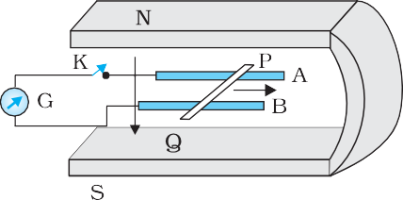

**FIGURE 6.20**

* + 1. Is there an excess charge built up at the ends of the rods when K is open? What if K is closed?
    2. With K open and the rod moving uniformly, there is *no net force* on the electrons in the rod PQ even though they do

###### 231

experience magnetic force due to the motion of the rod. Explain.

* + 1. What is the retarding force on the rod when K is closed?
    2. How much power is required (by an external agent) to keep the rod moving at the same speed (=12 cm s–1) when K is closed? How much power is required when K is open?

( f ) How much power is dissipated as heat in the closed circuit?

What is the source of this power?

(g) What is the induced emf in the moving rod if the magnetic field is parallel to the rails instead of being perpendicular?

* 1. An air-cored solenoid with length 30 cm, area of cross-section 25 cm2 and number of turns 500, carries a current of 2.5 A. The current is suddenly switched off in a brief time of 10–3 s. How much is the average back emf induced across the ends of the open switch in the circuit? Ignore the variation in magnetic field near the ends of the solenoid.
  2. (a) Obtain an expression for the mutual inductance between a long straight wire and a square loop of side *a* as shown in Fig. 6.21.

(b) Now assume that the straight wire carries a current of 50 A and the loop is moved to the right with a constant velocity, *v* = 10 m/s. Calculate the induced emf in the loop at the instant when *x* = 0.2 m. Take *a* = 0.1 m and assume that the loop has a large resistance.



**FIGURE 6.21**

* 1. A line charge ** per unit length is lodged uniformly onto the rim of a wheel of mass *M* and radius *R*. The wheel has light non-conducting spokes and is free to rotate without friction about its axis (Fig. 6.22). A uniform magnetic field extends over a circular region within the rim. It is given by,

**B** = – B0 **k** (*r*  *a*; *a* < *R*)

= 0 (otherwise)

What is the angular velocity of the wheel after the field is suddenly switched off ?

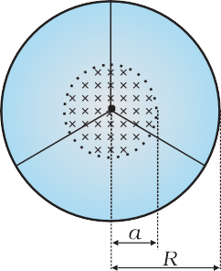

###### 232

**FIGURE 6.22**